Revolution Art: Web Application

Business Requirements Document

Project: Revolution Art: Web Application

Author(s): Kishore Kanchan, Rufan Mirganiyev, Louise Ngo,

Melika Zandikarimi, Jianan Jiang, Zo DiSanto, Shanshan Li

TABLE OF CONTENTS

**1. Project Overview** **3**

1.2 Glossary of Terms 3

**2. Document Information** **4**

2.1 Audience 4

**3. Business Opportunity** **4**

3.1 Project Overview and Background 4

3.2 Current State Analysis 4

3.3 Future State Objectives 5

3.4 Stakeholders 5

**4. Business Requirements** **5**

4.1 Business Scope 5

4.2 Details of Business Requirements 6

4.2.1 Financing Group 6

4.2.2 Advertisers 6

4.2.3 Suppliers 6

4.2.4 Customer Requirements 6

**5. Non-Functional Requirements** **6**

**6. External Data Feeds** **8**

6.1 Process Payment 8

6.1.1 Enables the clients to pay, electronically, for the piece they are interested to purchase 8

6.1.2 Enables the galleries to pay, electronically, for their subscription 8

6.2 Order Products 8

6.2.1 Order information is documented and change relevant information such as stock number of the piece and feeds notification that the payment is cleared to process the order 8

6.2.2 purchased artwork is sent to corresponding supplier and shipped to customer 8

6.3 Display Ads 8

6.3.1 Advertisements are run based on the client’s previous purchases and interests 8

6.4 Customer Support System 8

6.4.1 Form submission that the customers can use to contact customer service, submit the complaints for resolution and get answers to their inquiries. 8

6.4.2 Allows the customer service department system to feed the information to the client’s account with the answers to customer’s information inquiries, and update the clients on their submitted complaints by providing the information received from the source of the issue and providing the resolution. 8

**7. Business Risks** **8**

# Project Overview

This document describes the business/user requirements for Revolution Art’s Website Application that will provide a basis for the following project activities:

* Introducing business/user requirements
* Creating test plans and test specifications
* Identifying stakeholders
* Devising solutions to project tasks
* Produce an web application that will enable users to buy high-end artwork directly from the website
* Determining when the project is complete
* Assessing the degree to which the project succeeded

## 1.2 Glossary of Terms

| **Term** | **Definition** |
| --- | --- |
| Suppliers | Revolution Art’s supplier’s base covers Galleries that gather artworks from different artists as products and art handlers. |
| Customers | This project has two different types of customers, the first being the galleries that subscribe to the platform and are able to post artwork to the website. The second type are the clients that purchase the artworks. |
| Target Market | This is defined as the overall customer group that Revolution Art is designed to serve. |

# Document Information

## 2.1 Audience

| **Name** | **Business Unit** | **Role** |
| --- | --- | --- |
| Gallerists | Subscription / Account Management | Partner / Supplier |
| Collectors / Clients | Customer Support Team | Partner / Supplier |
| Art Dealers / Advisors | Customer Support Team | Partner / Supplier |
| Ads Agency | Advertising Team | Partner / Investor |
| Finance Team | Customer Payment Management | Web Application Users |

# Business Opportunity

## 3.1 Project Overview and Background

Our goal is to create a web application that connects two different categories of people together (Galleries and collectors). Galleries can sell their artworks through our platform to the people interested in acquiring artworks. The Web Application will also allow the user to follow, view, or attend various art venues based on their profile, purchase history, and information provided when creating their profiles. Revolution Art is an easy to use interface that will provide an easy purchase with art market market analytics.

## 3.2 Current State Analysis

The art industry has gotten more attention over the years and it is becoming one of the great ways to invest money. People these days are getting more drawn to invest their money and at the same time be able to look at their investment and feel joy. Before the online art marketplaces take a huge part of this industry, collectors had to dig deep in order to find the right choice and make sure that they are investing in the right artwork. The online art marketplaces make this experience easier. Revolution Art will be a bridge between galleries and people looking for artworks by connecting them to one another and creating an easy to use platform for both customers (galleries and clients). Examples of these sites are Artsy.net , theartpledge.org and emergeast.com and so many others. Revolution Art will provide consumers with a similar service utilizing an attractive interface. The project will be built upon React Framework and will use JavaScript for front-end development. The back-end will use a database produced by MongoDB. The planning process for the application is currently underway, and the development of the project will span two semesters at Pace University.

## 3.3 Future State Objectives

The objective is to create a web application that will be able to compete in the crowded marketplace of art websites. The website will offer a vast variety of options from emerging artists to established ones. And people who are interested in purchasing art, can find and purchase art with a few clicks.

## 3.4 Stakeholders

| **Stakeholders** |
| --- |
| Subscribed Clients |
| Galleries |
| Customer Support Team |
| Advertising Team |
| Finance Management |
| Subscription / Account Management |
| Credit Card Vendors |
| Delivery Services / Art Handlers |

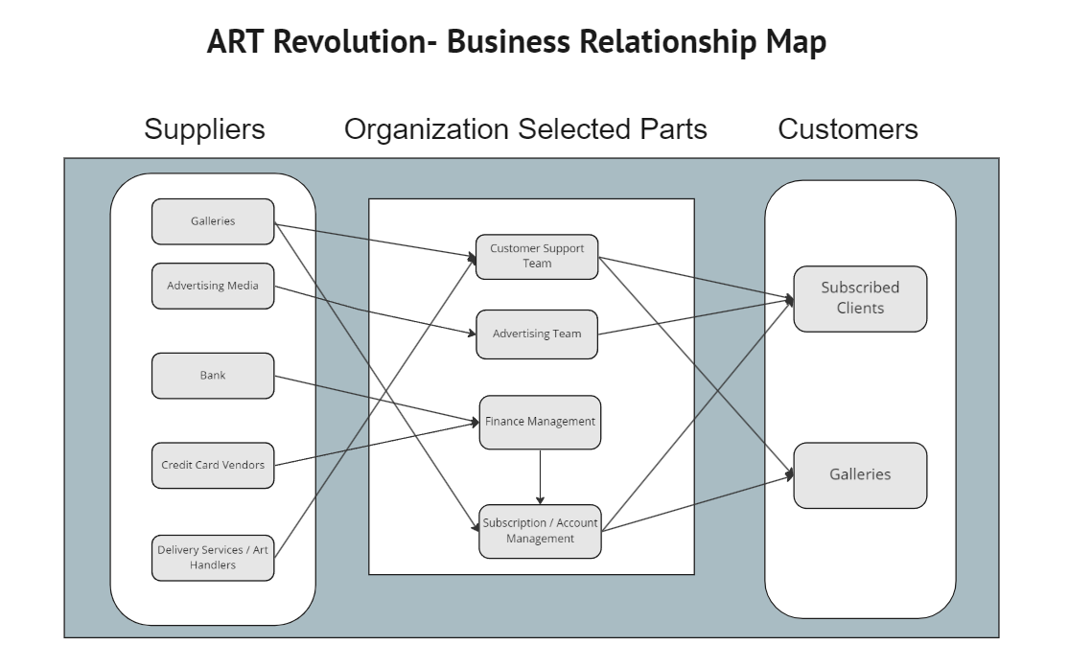

# Business Requirements

## 4.1 Business Scope

There are two sides to our business scope, one are the galleries and the other ones are the clients using the web application. Galleries upload the selection they are willing to sell on the web application and the clients will be able to directly purchase their desired works from that gallery online and it will be delivered to them within two weeks. Revolution Art will be structured as a web application that will be financed through subscription with galleries and taking a commission fee through client’s purchases.

## 4.2 Details of Business Requirements

### **4.2.1 Financing Group**

4.2.1.1 Ability to allow payment processing

4.2.1.2 Ability to verify payment form (i.e. check credit card activation)

4.2.1.3 Ability to post order amount on customer’s account on Revolution Art

4.2.1.4 Ability to post order amount on customer’s corresponding bank statement

### **4.2.2 Advertisers**

4.2.2.1 Ability to view user browsing history within the website only

4.2.2.2 Ability to filter advertisements list on Revolution Art based on user preference

4.2.2.3 Ability to keep ads up-to-date

### **4.2.3** Subscription and Account Management

### 4.2.3.1 Ability to select a subscription plan according to the needs of the user. (Galleries and Clients)

4.2.3.2 Ability to select recurring payment if required.

4.2.3.3 Ability to cancel subscription.

4.2.3.4 Ability to agree to the privacy policy and terms and conditions. (Galleries and Clients)

4.2.3.5 Ability to see the history of purchase (Clients)

### **4.2.4 Customer Requirements**

4.2.4.1 Ability to open up web page (Galleries and clients)

4.2.4.2 Ability to log in to website and have complete control of customer

account - such as editing account information or deleting account if

needed (Galleries and clients)

4.2.4.3 Ability to sign-in to pre-existing account

4.2.4.4 Galleries should be able to enter all the information for each artwork currently in their portal.

4.2.4.5 Ability for customers (Galleries and Clients) to use customer support services if encountering any issues.

4.2.4.6 Ability to rate the artwork, artist and services and leave reviews. (Client)

# Non-Functional Requirements

| Category | Requirements |
| --- | --- |
| Usability | The application's GUI interface should feature a minimalistic and intuitive design, with menu options clearly labeled and field functions obvious to any user ensuring seamless and hassle free navigation between pages. |
| Usability | The purpose of any section of the application should be immediately evident to any user. |
| Usability | The application should be easy to navigate and users should be able to immediately access any significant functionality that they may need within a few clicks, ideally in one click. The call to action buttons should be available on the first section of the homepage helping customers choose what they want to do right after they land on the website. |
| Performance | The response time of the application should not be impacted by latency that will significantly impact the evident availability of application features or information. |
| Performance | The application should be available for users 24 hours a day, every day of the year. |
| Performance | The application should not make excessive demands on the customer's computer or device memory capabilities. |
| Performance | The application should support several users at the same time. |
| Security | The application will be protected from hackers and intrusion by various security measures. |
| Security | Encryption for customer's personal data that is maintained on the web application's server. |
| Database | Application will use the MongoDB database. |
| External System | Application will be able to interface successfully with social media websites, art product websites, credit card payment services, and other online resources. |

# External Data Feeds

## 6.1 Process Payment

### 6.1.1 Enables the clients to pay, electronically, for the piece of art that they are interested in purchasing.

### 6.1.2 Enables the galleries to pay, electronically, for their subscription.

## 6.2 Order Products

### 6.2.1 Order information is documented and relevant information is updated, such as the stock number of a given art piece and notification feeds that the payment is cleared to process the order.

### 6.2.2 Purchased artwork is sent to the corresponding supplier and shipped to the customer.

## 6.3 Display Ads

### 6.3.1 Advertisements are run based on the client’s previous purchases and interests.

## 6.4 Customer Support System

### 6.4.1 Form submission that the customers can fill out to contact customer service. Upon submitting the complaints for resolution, customers will also get answers to their inquiries.

### 6.4.2 Allows the customer service department system to feed the information to the client’s account with the answers to customer’s information inquiries. This will update the clients on their submitted complaints by providing the information received from the source of the issue and providing the resolution.

# Business Risks

There are many websites/applications that provide the same service as the service we want to provide. The market is very competitive. One key strategy to mitigate this risk is by keeping our website user-friendly, simple to use with a continually growing list of artworks and new features that makes product browsing and purchasing less of a hassle for users. Having a mobile app running in parallel to the website is a good way to compete (this would be completed at a later stage of development). Another way is to constantly advertise and notify users of new deals and newly listed artworks, either through ads or by email. We can do advertising to attract buyers, but first we will need sellers. Therefore, at the beginning, we can have artists/galleries publishing their artworks on our websites for free, and they will pay us “commision” - meaning we get paid when they sell something.